**Assignment on Exception handling**

1) Write an application that accepts two numbers, divides the first number with the second number and display the result. Hint: You need to handle ArithmeticException which is thrown when there is an attempt to divide a number by zero.

**package** myClass;

**import** java.util.*;

**public** **class** devide {

**public** **static** **void** main(String[] args) {

Scanner sc= **new** Scanner(System.***in***);

System.***out***.println("enter 1st number: ");

**int** a=sc.nextInt();

System.***out***.println("enter 2st number: ");

**int** b=sc.nextInt();

**try**{

System.***out***.println(a/0);

}

**catch**(ArithmeticException e )

{

System.***out***.println(a/b);

}

}

}

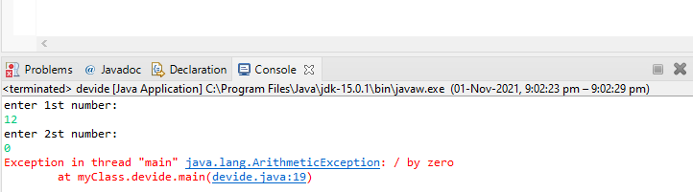

3) Write an application to perform withdraw functionality on a SavingAccount object. Point to note:

a. Raise InsufficientBalanceException if you are trying to withdraw more than balance or when you balance is zero. E.g. if you balance is 2000 and if you are trying to withdraw 2100 or if you balance is 0 and you are trying to withdraw positive value.

b. Raise IllegalBank TransactionException if you are trying to withdraw a negative value from your balance. E.g. if you try to withdraw a negative value savingAcc.withdraw( 1000);

**package** myClass;

**public** **class** InsuffecentbalanceException **extends** RuntimeException {

InsuffecentbalanceException(String msg){

**super**(msg);

}

}

**package** myClass;

**public** **class** illegalBankTrasactionException **extends** RuntimeException {

illegalBankTrasactionException(String msg)

{

**super**(msg);

}

}

**package** myClass;

**public** **class** SavingAccount {

**long** id;

**static** **double** *balance*;

SavingAccount(**long** id , **long** bal){

**this**.id=id;

SavingAccount.*balance*=bal;

}

**static** **void** withDraw(**double** amount) {

**if**(amount<=0)

{

**throw** **new** illegalBankTrasactionException("you are trying to withdraw a negative value");

}

**if**(*balance*<amount) {

**throw** **new** InsuffecentbalanceException("You are Trying to withDraw"+ amount);

}

**else**

{

System.***out***.println("Please take the money");

}

}

**void** diposti(**double** amount) {

*balance*=*balance*+amount;

}

**public** **static** **void** main(String[] args) {

SavingAccount s1= **new** SavingAccount(123,2000);

//SavingAccount.withDraw(2100);

SavingAccount.*withDraw*(-100);

}

}

